COURSE CODE/TITLE: | CPE 010 |  | SECTION: | CPE21S3
DATE PERFORMED: | 9/8/26 |  | DATE SUBMITTED: | 9/10/26
NAME: | Ralf Nicolo B. Abello |  | INSTRUCTOR: | Engr. Jimlord Quejado

ACTIVITY NO. 7.1 | Sorting Algorithms Pt1
1. PROCEDURE OUTPUT
Code + Console Screenshot | 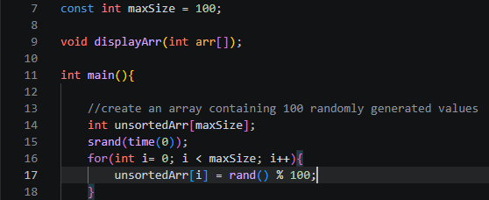
Observations | The array holds 100 random integers ranging from 0-99, generated using rand() % 100. Since srand(time(0)) seeds the random generator with the current time, the array is different every time the program runs. This unsorted array is reused as the input for all three sorting techniques so the comparisons between them are fair. Using a fixed size of 100 also gives a large enough dataset to clearly see differences in how each algorithm performs.
Table 7-1. Array of Values for Sort Algorithm Testing

Code + Console Screenshot | 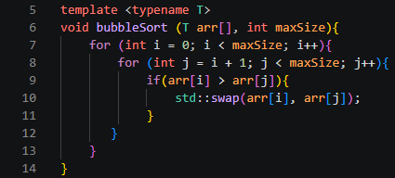
Observations | bubbleSort uses two nested loops, an outer loop that runs 100 times (once per element) and an inner loop that runs from i+1 to maxSize for each outer pass. On each pass, it compares arr[i] to every later element and swaps whenever arr[i] > arr[j], gradually placing smaller elements earlier in the array. Since the inner loop shrinks by one each pass, the total number of comparisons follows n(n-1)/2, giving it a time complexity of O(n²). It always runs this many comparisons regardless of how sorted the input already is, since there's no early-exit check for a sorted pass.
Table 7-2. Bubble Sort Technique

Code + Console Screenshot | 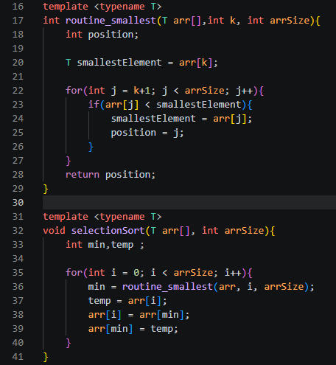
Observations | selectionSort has an outer loop that runs 100 times, and on each pass it calls routine_smallest, which contains its own loop that scans the remaining unsorted portion of the array to find the smallest value's index. This nested loop code means the total number of comparisons also follows n(n-1)/2, giving it the same O(n²) time complexity as bubbleSort. The key difference is that selectionSort only performs one swap per pass (100 swaps total), compared to potentially many swaps in bubbleSort. This makes it more efficient in terms of writes, even though the comparison count and overall complexity are the same.
Table 7-3. Selection Sort Algorithm

Code + Console Screenshot | 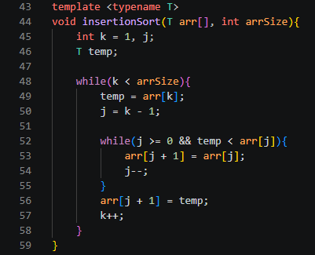
Observations | insertionSort uses an outer while loop that runs 99 times, starting at k=1 since the first element is already treated as sorted on its own. On each pass, the inner while loop shifts elements greater than temp one position to the right until it finds temp's correct spot, so the number of inner loop iterations varies depending on how much of the array is already sorted. In the worst case, this still totals n(n-1)/2 comparisons, giving it a worst case time complexity of O(n²), but on a nearly sorted array the inner loop can exit almost immediately, making it much faster in practice.
Table 7-4. Insertion Sort Algorithm

2. ANSWERS TO SUPPLEMENTAL ACTIVITY
Pseudocode
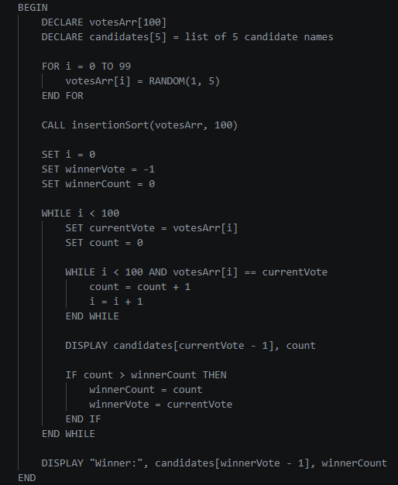

Code
suppMain.cpp
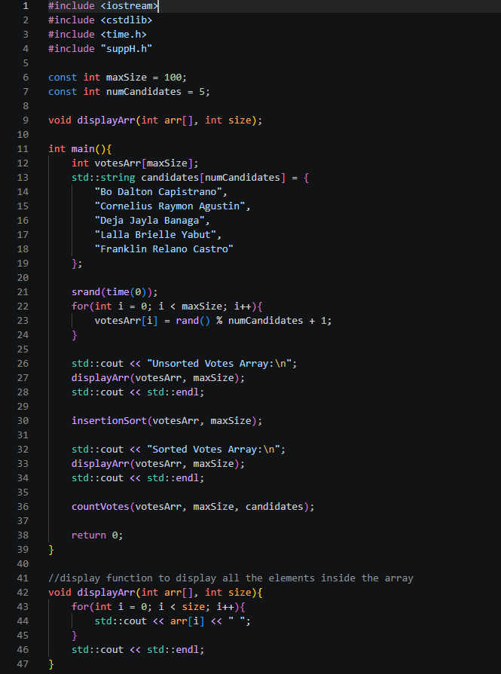
suppH.h
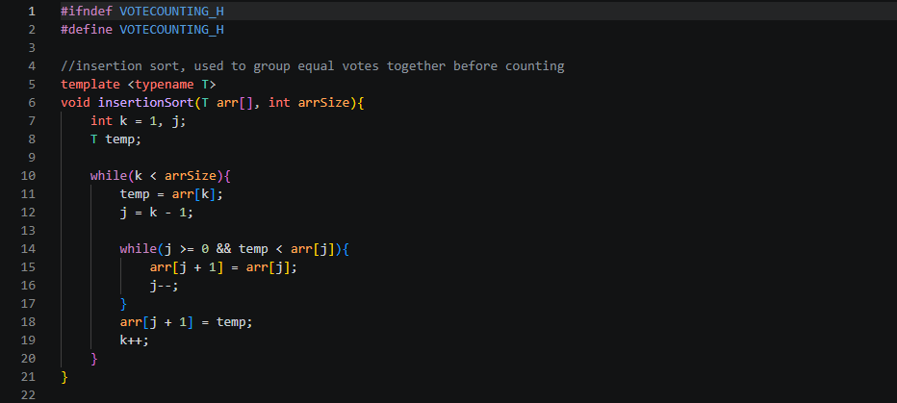
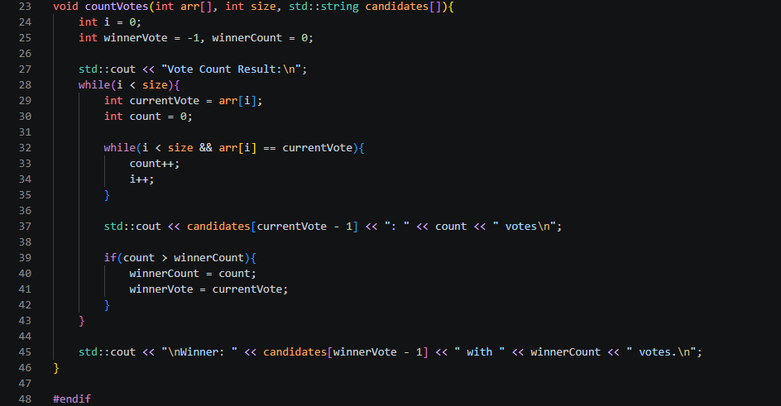

Output Console Showing Sorted Array | Manual Count | Count Result of Algorithm
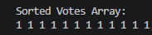  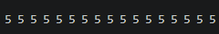 | 1: 12  2: 20  3: 26  4: 25  5: 17 | 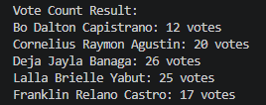

Question: Was your developed vote counting algorithm effective? Why or why not?
Yes, my vote counting algorithm was effective because sorting the array first meant every vote for the same candidate ended up next to each other, letting me count all the votes in a single linear pass using run-length counting instead of needing a separate counts array or repeated searches through the list. Since I used insertion sort, the overall approach stayed efficient for this dataset since maxSize is only 100 elements, and the counting step itself only added an extra O(n) pass on top of the sort. The main tradeoff is that this method depends entirely on the array being sorted beforehand, so if I had skipped the sort or used an unsorted array, the run-length counting logic would break and give inaccurate vote totals. Overall, this made the algorithm simple, accurate, and well suited for a small, fixed range of candidate values like 1-5.

Conclusion
Through this activity, I learned how bubble sort, selection sort, and insertion sort each work at the code level and how their loop structures affect performance, since all three have a worst case time complexity of O(n²) but differ in the number of actual comparisons and swaps they perform. For the main procedure, I generated a 100-element array of random integers using rand() % 100 and ran it through bubbleSort, selectionSort, and insertionSort from sorting.h, confirming that bubbleSort did the most comparisons and swaps since it lacks an early exit, selectionSort minimized swaps to one per pass, and insertionSort shifted elements based on how much of the array was already in order. For the supplementary activity, I built a separate voteCounting.h with its own insertionSort implementation and a countVotes function that scans the sorted array and counts consecutive runs of the same vote value to find the winning candidate, which worked well since sorting grouped all votes for the same candidate together and let me count them in a single linear pass. Overall, I think I did well since I implemented all three sorting algorithms correctly and applied insertion sort to a practical vote counting problem, though one area I could improve on is testing edge cases more thoroughly, like an empty or already sorted array.

3. ARTIFICIAL INTELLIGENCE (AI) USE DISCLOSURE STATEMENT
I hereby declare that artificial intelligence (AI) tools were used, if applicable, in the preparation of this academic work. The following indicates the nature and extent of AI assistance:

Tools Used: | ChatGPT & Grammarly
Examples: ChatGPT, Microsoft Copilot, Grammarly, QuillBot, etc.

Purpose of Use: | Grammar correction & code assistance
Examples: grammar correction, idea generation, formatting, summarization, code assistance, explanation of concepts, etc.

Extent of Use: | Used for assisting/debugging code and grammarly for writing proper grammar
Explain how AI was used and confirm that it did not replace original thinking, analysis, authorship, or completion of the required work.

By submitting this activity, I affirm that my use of AI complies with T.I.P.’s AI usage policy and does not exceed the permitted limits for similarity, automated content generation, or academic assistance.

I understand that any false, incomplete, or misleading disclosure may be subject to investigation in accordance with due process and may result in sanctions for violation of existing T.I.P. policies.

Lab activities, templates, and related instructional materials shall not be reuploaded, reproduced, distributed, or shared with external organizations or third parties without the prior express written permission of the Technological Institute of the Philippines.

